ASSIGNMENT 14

**Task 1: Create a Responsive Web Page Layout**

**Instructions:**

* Design a basic web page layout with a **header, main content area, and footer** using HTML and CSS.
* Use AI to assist in generating **responsive CSS** for different screen sizes.
* Ensure the layout is clean and visually organized.

**Expected Output:**

* A responsive web page with:
  + Header with navigation links
  + Main section with placeholder text/images
  + Footer with copyright or contact info

Layout adapts correctly to desktop, tablet, and mobile screen sizes

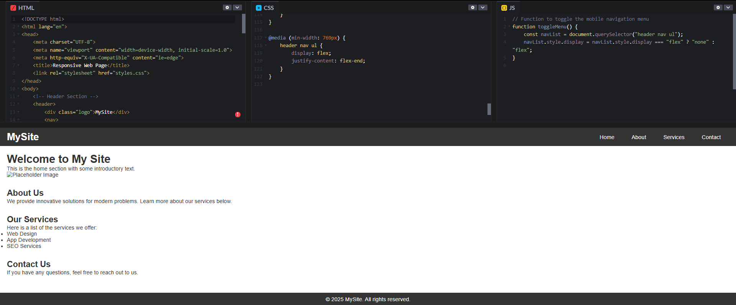

**Task 2: Interactive Button with JavaScript**

**Instructions:**

* Create a **button** on a web page.
* Use AI to generate JavaScript code that displays an **alert message** when the button is clicked.
* Ensure the code is clean and well-commented.

**Expected Output:**

* A web page with a button.
* Clicking the button shows a pop-up alert message, e.g., “Button clicked!”.

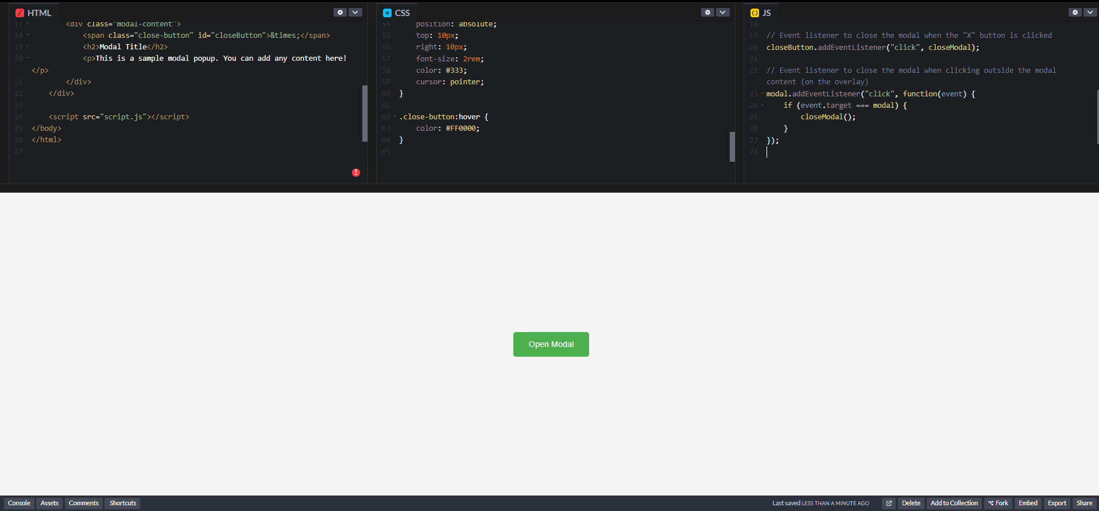

**Task 3: Form with Validation**

**Instructions:**

* Design a **contact form** with fields: Name, Email, Message.
* Use AI to generate JavaScript code for **form validation** (e.g., non-empty fields, valid email format).
* Add **inline error messages** if input is invalid.

**Expected Output:**

* A functional contact form where:
  + Submitting with empty fields shows error messages.
  + Submitting with valid input displays a “Form submitted successfully” message.

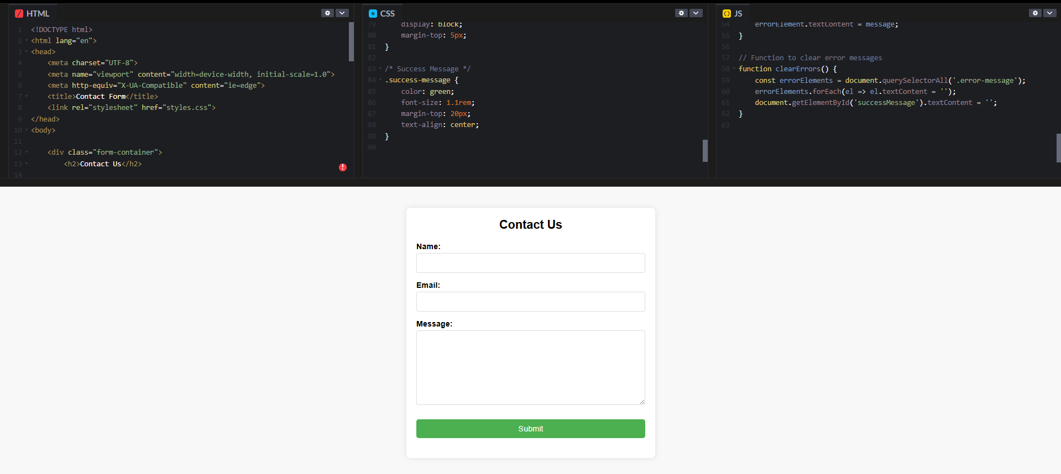

**Task 4: Dynamic Content Generation**

**Instructions:**

* Create a list of items (e.g., product names) using **HTML**.
* Use AI-generated JavaScript to **dynamically add or remove items** from the list when a button is clicked.

**Expected Output:**

* A web page with a list and buttons:
  + “Add Item” adds a new item to the list dynamically.
  + “Remove Item” deletes the last item.
* Updates occur without reloading the page.

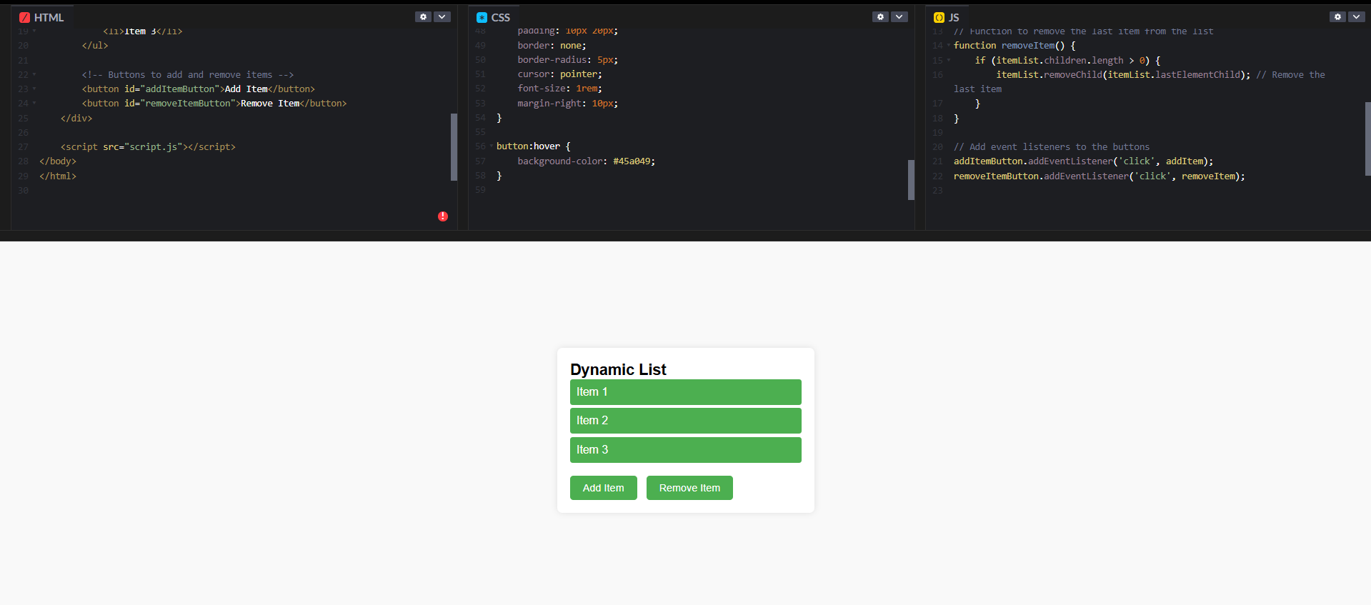

**Task 5: Styled Modal Popup**

**Instructions:**

* Use AI to generate a modal popup that opens when a button is clicked.
* Style the modal using CSS with a semi-transparent overlay.
* Include a close button that hides the modal.

**Expected Output:**

* A web page with a button labeled “Open Modal”.
* Clicking the button displays the modal popup with content.
* Modal can be closed by clicking the “X” button or overlay area.

